**ASSIGNMENT 2**

**Kulsoom Khurshid**

**SP20-BCS-044**

**TASK 1**

This dataset is related to flowers. There are four characteristics i.e., sepal length, sepal width, petal length and petal width. On the basis of these characteristics classification is made whether the flower is Setosa, Versicolor and Virginica. This dataset is divided in two, half data is used to train the model whereas the other half is used for testing to check if the flower is correctly categorized.

***import seaborn as sns***

This library that I have used to load the Iris dataset.

The two algorithms that we have used are Logistic regression and Decision Tree.

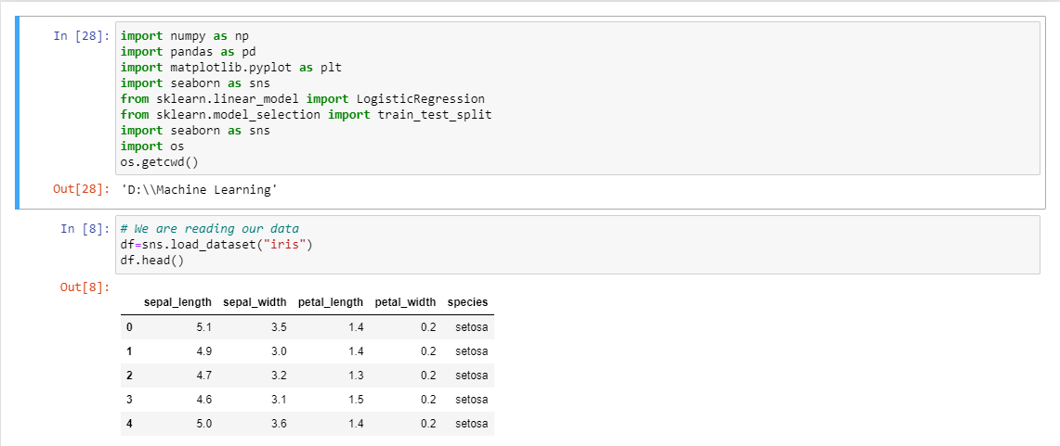

**TASK 2**

df.describe()

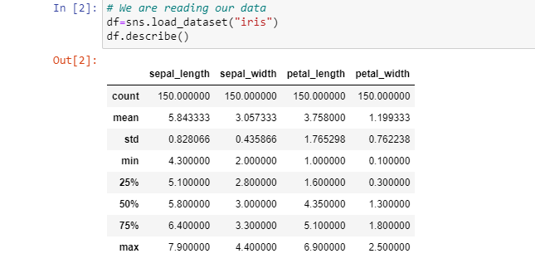

df.info()

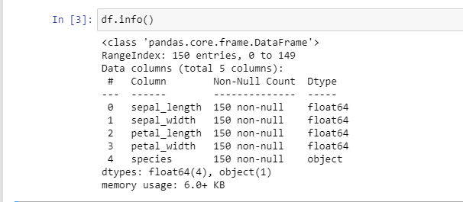

**TASK 3**

Logistic Regression

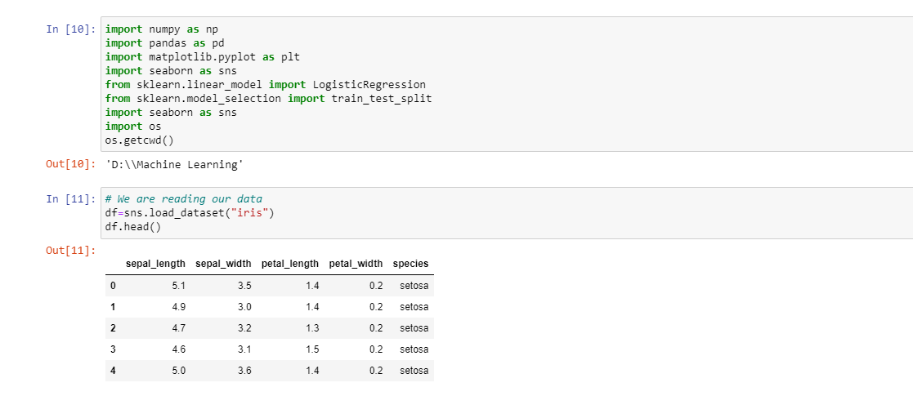

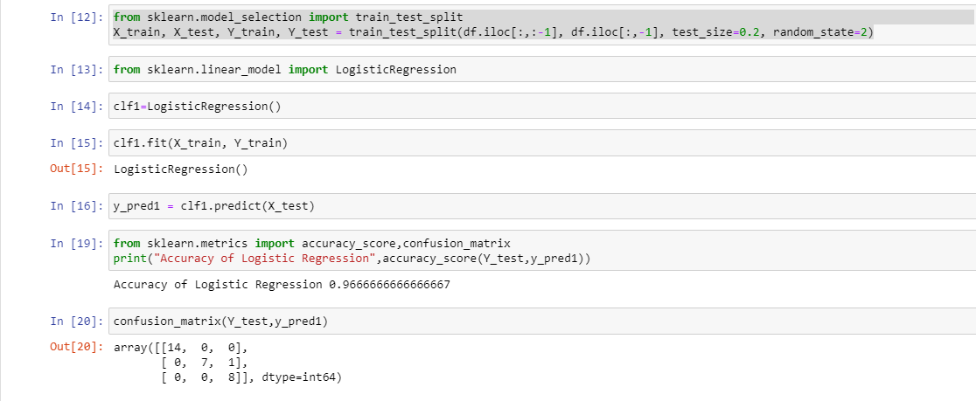

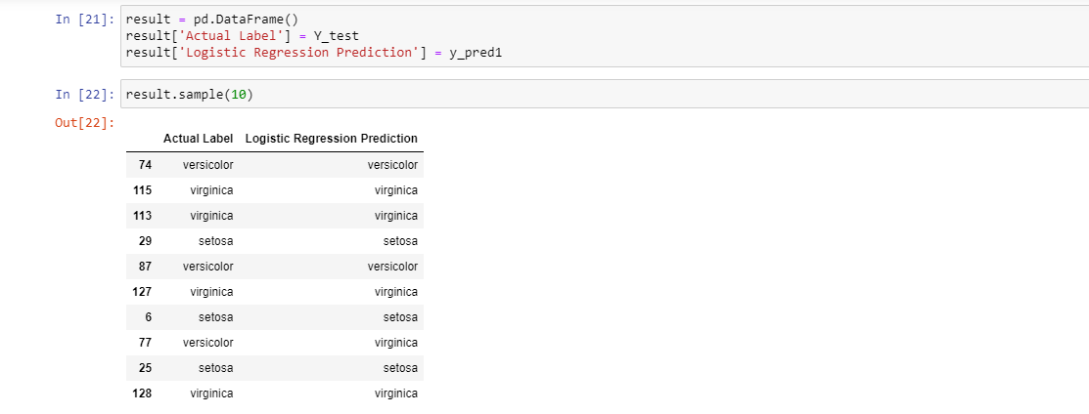

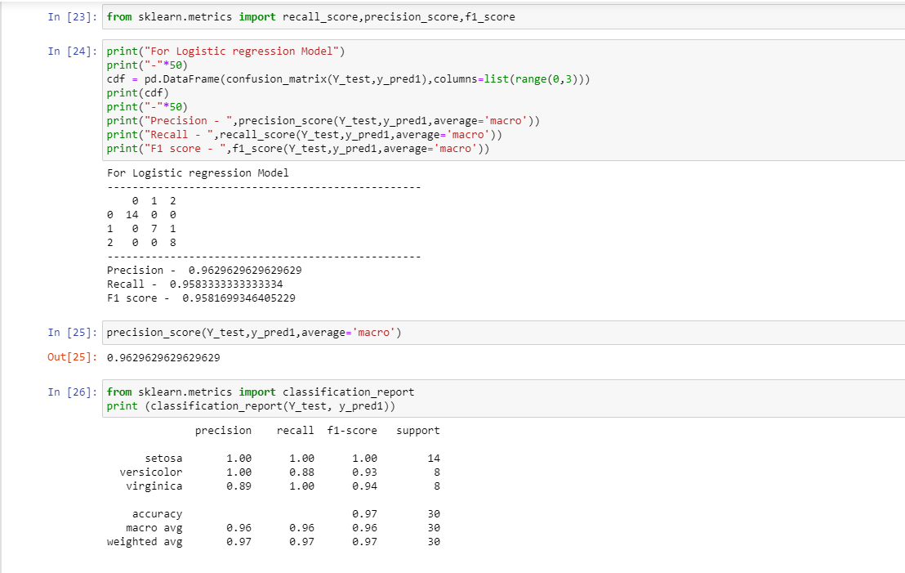

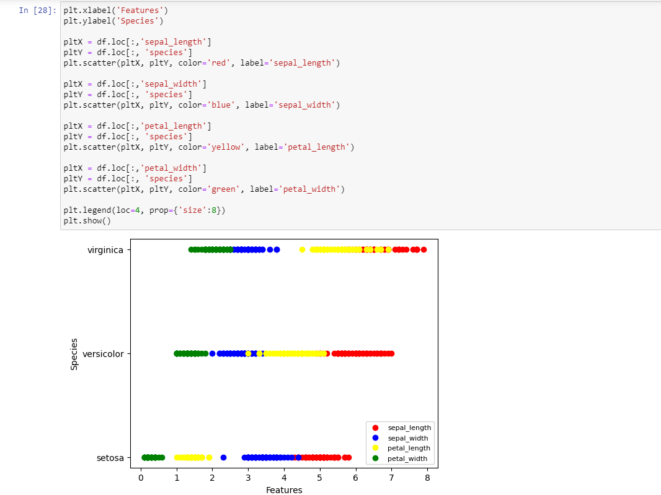

**TASK 4**

Decision Tree

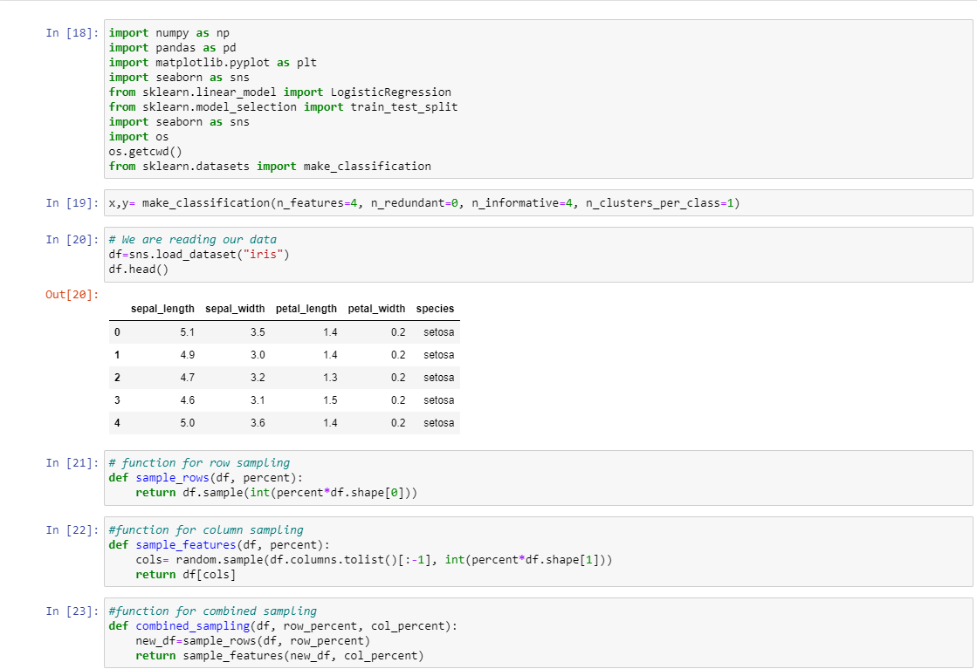

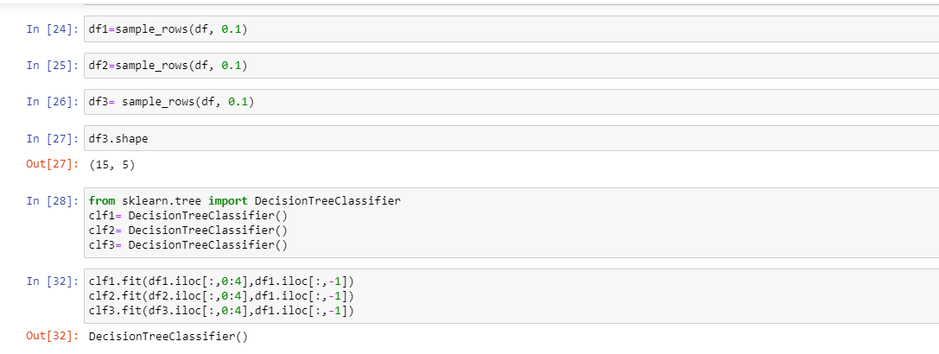

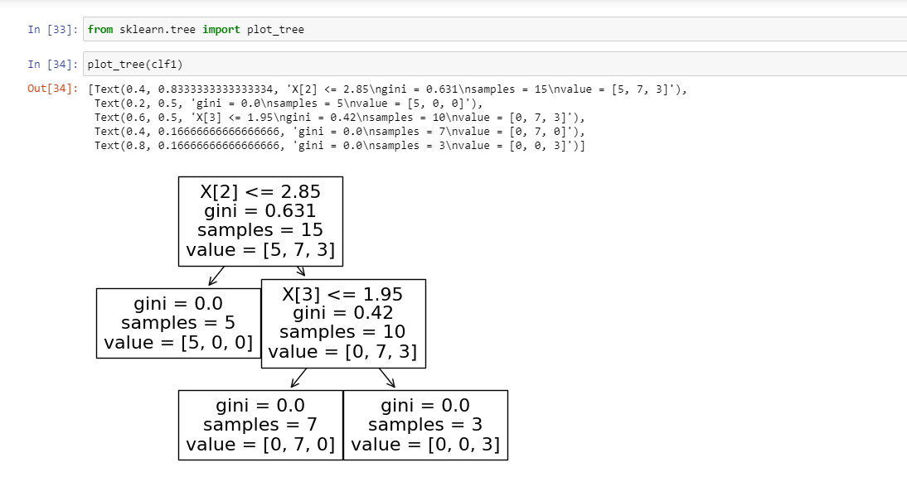

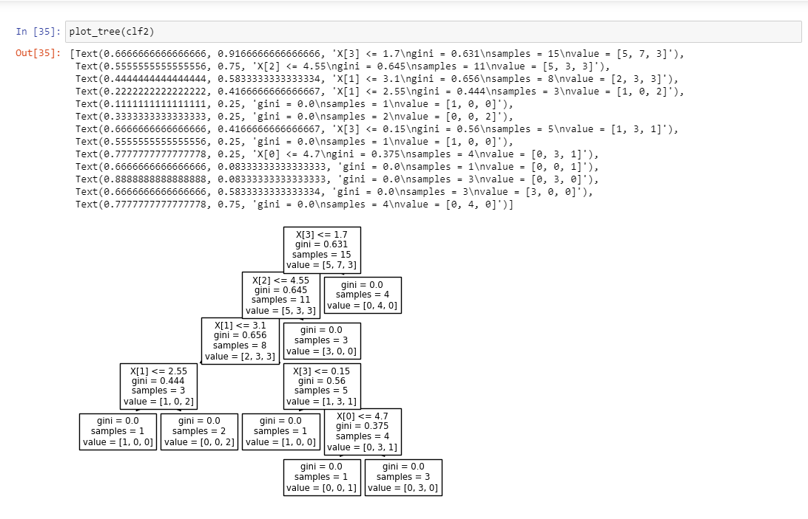

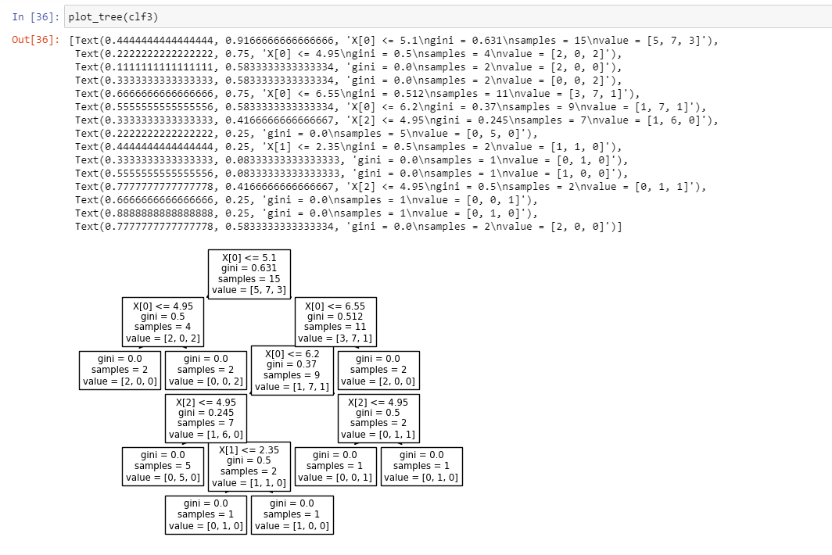

**TASK 5**

